**SESSION 1**

<?xml version="1.0"?>

<DOCUMENT>

<GREETING>

Chào các bạn

</GREETING>

<MESSAGE>

Chào các bạn đến với XML

</MESSAGE>

</DOCUMENT>

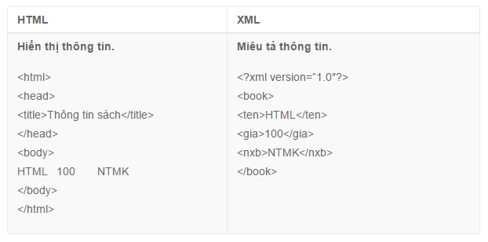

**SESSION 2: NAMESPACE**

**Cách 1:**

<?xml version="1.0" encoding="UTF-8"?>

<!-- Declare NameSpace in root-->

<doc

xmlns:h="http://localhost/html"

xmlns:f="http://localhost/furniture">

<!-- Use namespace -->

<!-- HTML table information -->

<h:table>

<h:tr>

<h:td>Apples</h:td>

<h:td>Bananas</h:td>

</h:tr>

</h:table>

<!-- information about a table (furniture) -->

<f:table>

<f:name>African Coffee Table</f:name>

<f:width>80</f:width>

<f:length>120</f:length>

</f:table>

</doc>

**Cách 2:**

<?xml version="1.0" encoding="UTF-8"?>

<doc>

<f:table xmlns:f="http://localhost/furniture">

<f:name>African Coffee Table</f:name>

<f:width>80</f:width>

<f:length>120</f:length>

</f:table>

<h:table xmlns:h="http://localhost/html">

<h:tr>

<h:td>Apples</h:td>

<h:td>Bananas</h:td>

</h:tr>

</h:table>

</doc>